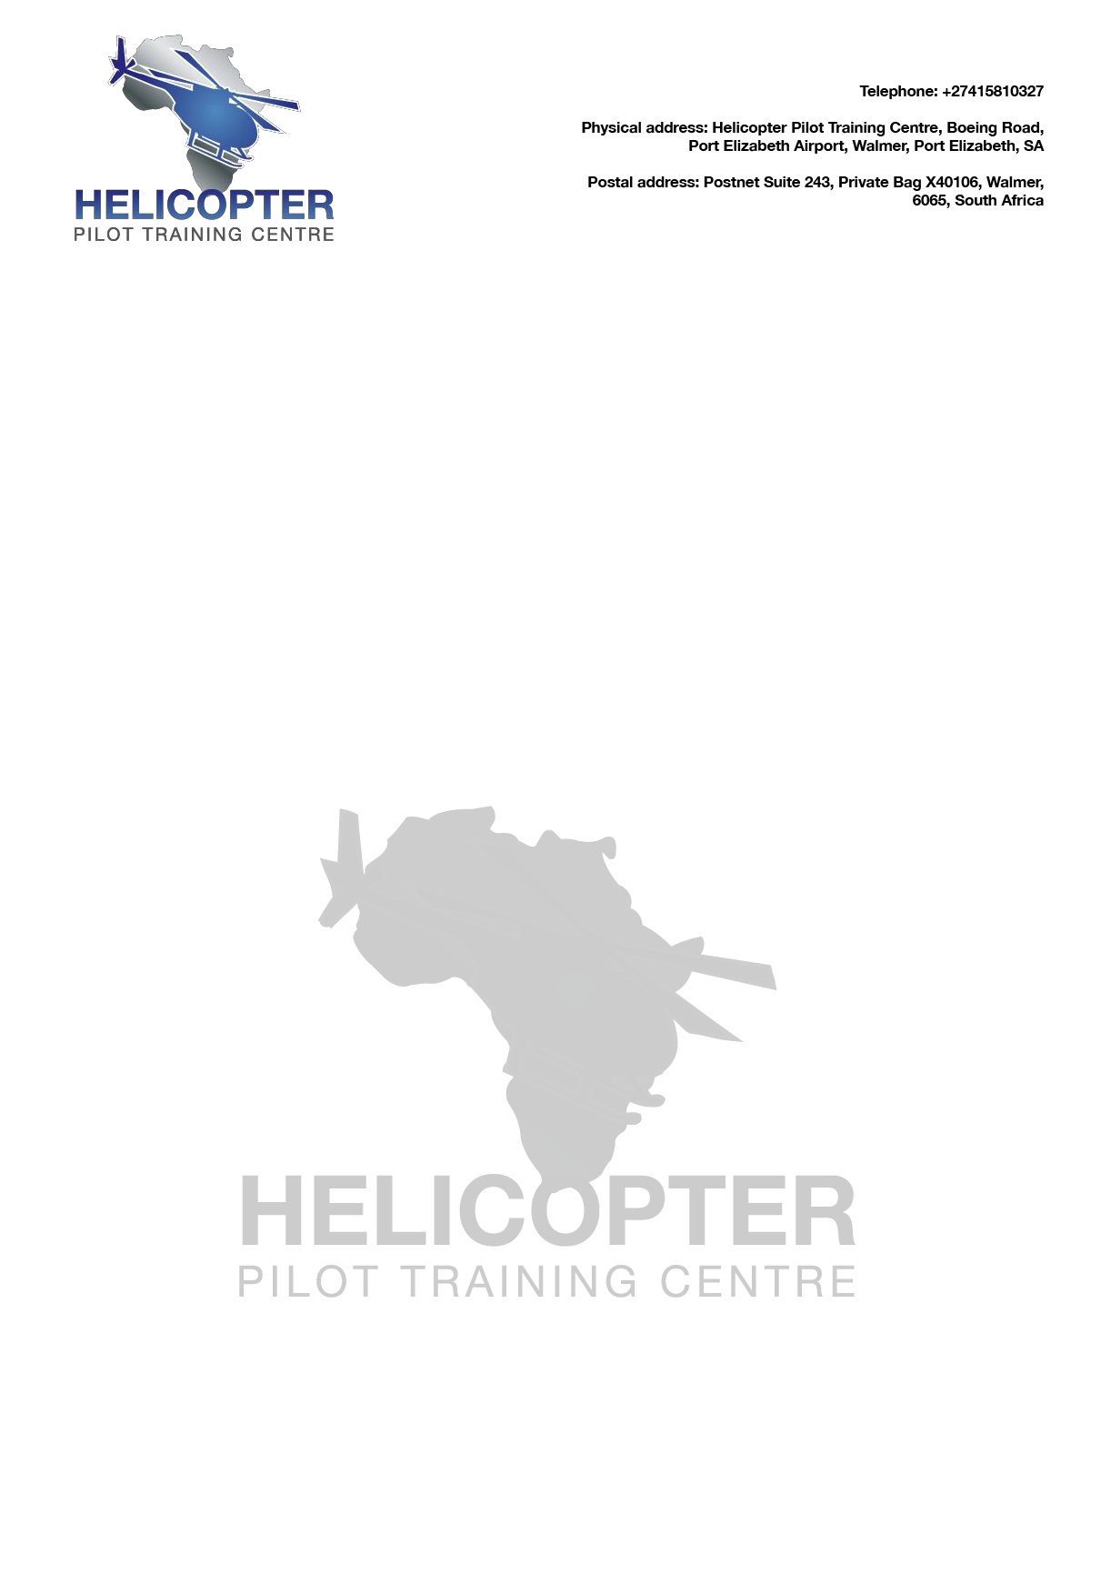

HELICOPTER PILOT TRAINING CENTRE ENROLMENT FORM
APPLICANT INFORMATION
Name:
Date of birth: | Nationality: | Phone:
I.D/Passport Number:
Current address:
TRAINING INFORMATION
I am applying for: (TICK APPLICABLE)
-  PPL (H)
-  Night rating (Only after completing your PPL)
-  CPL (H)
4)  Instructors rating
Note:
WHEN WOULD YOU LIKE TO COMMENCE TRAINING?
WOULD YOU NEED A STUDENT VISA?
NEXT OF KIN
Name :
Address: |  | Phone:
City: | Email:
Relationship:
P r e v i o u s F l y i n g E x p e r i e n c e
Licence Held
Country of Issue :
Hours:
HOW DID YOU HEAR ABOUT US?
Student signature Sponsor signature or Parent / guardian if under 18

Print Name: Print Name:
Date: Date:

